Heterosexual Objectification within Popular Music in 2017

Julie Norman, Emma Thompson, Max White, Samm Hernandez

# Abstract

In this study, our analysis was centered on 240 of Spotify’s most streamed songs of 2017, organized by genres. These genres were organized as playlists from which the top 30 were reviewed and coded with our system to determine the proportions and frequency in which male or female singers were talking about members of the opposite sex, lyrically. Our research found that there was no statistically significant difference between male and female singers talking about any member of the opposite sex.

Table of Contents

Abstract 2

Introduction 4

Literature Review 5

Methods 7

Coding Examples 8

Coding Quandaries 12

Statistical Analysis 14

General Data Visualization 14

Multinomial Probit Model 17

Singer Gender Analysis 18

Song Content by Singer Gender 19

Conclusions 20

References 22

# Introduction

In 2017 an average American listened to just over 32 hours of music per week (McIntyre, 2017). This was a large increase in play time from the two years prior and showed the success of streaming services like Apple Music, Pandora, and Spotify (McIntyre, 2017). In addition to 2017 being a big year for music, with 184 billion songs streamed by June of that year, 2017 was also an important year for women (McIntyre, 2017). Starting the year with the Women’s march and ending with overflowing recognition of the #MeToo movement, women in the United States were being heard and recognized. The question we wondered was, did 2017’s pop culture reflect that? Or more specifically, did 2017’s most streamed music reflect the dramatic shift in the recognition of the objectification of women and the unfair power dynamic men hold in society? We wanted to see just how much talk about gender and ‘doing something to another person’ comes into play in 2017’s music. Inspired by the Bechdel-Wallace type coding scheme we were able to notice different trends within the top 30 songs of different genres. The Bechdel-Wallace Test works as a litmus test to assess the presence of women in movies, so we wanted to do a similar litmus test but in popular music (F., 2009). In coding 240 of 2017 top songs, we hope to find a relationship between the discussion about men and women to the popularity of a song and the comparison of such between different genres. We hypothesized that the genre with the most objectification would be Rap and Country.

# Literature Review

Our study exists in a unique, but barely defined culture of work like it. Our methodology and application of gender to popular music by genre contained within Spotify is wholly unique to us, which is neat, but also novel. Other studies on gender distributions fall towards other mediums of analysis, such as in the studies *A Content Analysis of "Playboy" Centrefolds from 1953 through 1990: Changes in Explicitness, Objectification, and Model's Age* by Anthony F. Bogaert, Deborah A. Turkovich and Carolyn L. Hafer and *The Objectification of Women in Mainstream Pornographic Videos in Australia* by Alan McKee. Both studies follow a similar coding structure, although less rigorous and data heavy, and have a different emphasis of what they are looking for. While we coded for differences between men and women, the first study only looks for changes in objectification in women over a time frame. Most studies in this culture of research follow the same path, taking on multiple years as the basis for analysis whereas we were contained to 2017. The reviews these studies did were also within mediums that are more focused on women and not any differences to expression, as ours was.

The second type of study that exists in relation to ours is one that does look for gender in music, but on a regional basis. Not only are the specs regional, they are non-western, objecting the issue off of our shores and as an issue on the other side of the world. WE see this with studies like *Constructing Gender in Sundanese Music* by Sean Williams and *Gender and Sexuality in South African Music*. Ed. by Chris Walton and Stephanus Muller. These studies highlight a theme of dissecting a culture that is not your own through the lens of gender, applied to their music. Although done unconsciously, we as a group analyzed music of our diverse American culture, and the hypothesis and results were pertinent to our experiences. I think that's important in research, as it is a personal element that is often overlooked in favor of pursuing the image of objectiveness. We listen to some of this music, we are involved in the culture around it. Most of us even had Spotify. This test was done in our own metaphorical backyard. We also differed from this group of research as we did not stay within one genre, but went through many different styles. That was a pain, but provided a nice comparison that is intersectional and provides a foundation for this study to look at our topic across a wide and diverse medium.

# Methods

To properly understand the amount of objectification and sexism within the popular music of 2017, we first needed to decide what the popular music of 2017 was. Since we live in an age where music is not necessarily purchased, and 2017 was the year of streaming, we looked to one of the largest streaming services of today: Spotify. Spotify had different playlists of top songs of 2017 including a mix of different genres and also had a playlist of the top popular songs of that year. The different genre playlists we chose from were:

* Ultimate Indie
* Rock This
* RapCaviar
* Fresh Folk
* Hot country
* K-Pop (translated)
* Trap Land
* Top Christian Hits

We then researched the top thirty songs in each playlist, since a song is located on a Spotify playlist depending on the amount of streams it has received, and found the transcribed lyrics within the website A-Z Lyrics. There were some songs that were not in A-Z Lyrics, but most songs were found in said website.

It should be noted for K-Pop, all songs had the Korean, romanized, and translated versions, but for the purposes of this research only the English translation was used, since the coder did not speak Korean. Additionally, most of Trap Land it was Spanish Rap, not traditional “Trap Music.” While the lyrics were in Spanish but the coder for this genre speaks Spanish fluently and did not need to code translated lyrics.

To maintain the accuracy of the lyrics, all researchers listened to the songs while following the lyrics on the A-Z Lyric website. K-Pop was excluded from this stipulation because the coder did not speak Korean. After finding the lyrics for each songs, each line of lyric was coded. We did this by copying and pasting the lyrics from A-Z Lyrics and placing them in a word document, then highlighting and color coding based on the code we created. We developed a code that included six categories and the codes were:

* Man not talking about woman
* Man talking about woman
* Woman not talking about man
* Woman talking about man
* Romantic gender neutral
* Sexual Gender neutral

To keep consistency in the coding, individual coders reviewed a majority of another coder’s songs to make sure that everyone was coding lines the same way. Rules for why a line is coded a certain way will follow.

### Coding Examples

#### Man not talking about woman:

This category was coded as if the song had a male singer and the lyrics were about anything not relating to a woman or anything sexual or romantic.

Example: XO TOUR Llif3 by Lil Uzi Vert on RapCaviar

Are you alright?

I'm alright, I'm quite alright

And my money's right

8, yeah

Countin' them bands all way to the top, 'til they be fallin' over

Countin' them bands on my way to the top, 'til we fallin' over

Since these lyrics are not specifically mentioning a woman but are sung by a male singer, it was coded as “Man not talking about woman.” There is a “you” in the lyrics but since there is no qualifier to describe the gender, we did not want to code or assume the gender of the “you” in this stanza.

Man talking about women:

This was coded if the song had a male singer and the lyrics were about a woman. The lyric specifically needed to include words like “girl, lady, she, her, babe, baby, bitch, momma, mother, queen, princess, etc.”

Example: Oh NaNa by K.A.R.D on K-Pop

You lookin' for a man that's realer

Have fun all you want before you come to me

Insta, it's obvious what they're after

Shut out all their DM alarms

Girl, one shot

And all I see is you

All day, All night baby 365

I'm yours and I won't leave your side

The lyrics that are “Man talking about women” are in blue. Since these lyrics are specifically mentioning a woman and are sung by a male singer, it was coded as “Man talking about woman.” There is a “you” in the lyrics and since there is a qualifier later in the stanza with the use of the word “girl” we felt safe to assign a gender to the “you’s” within this stanza.

Woman not talking about man:

This was coded if the song had a female singer and the lyrics were about anything not relating to a man or anything sexual or romantic.

Example: Only Lonely by The Ballroom Thieves on Fresh Folk

My fingers are the only bones I want here  
She takes me when I share my den and turn my tide  
She knows I have a tendency  
I make mountains out of stones  
And with that timber, burn a hundred fires

Since these lyrics are not specifically mentioning a man but are sung by a female singer, it was coded as “Woman not talking about man.” There is a use of the word “she” but since we were not coding for female objectification of women rather one gender discussing another, this was coded as “Woman not talking about man.”

Woman talking about men

This was coded if the song had a female singer and the lyrics were about a man. The lyric specifically needed to include words like “boy, man, he, him, babe, baby, dad, father, king, etc.”

Example: Playing with fire by BlackPink on K-Pop

My mom told me every day

To always be careful of guys

Because love is like playing with fire

I'll get hurt

My mom might be right

Because when I see you, my heart gets hot

Because rather than fear

My attraction to you is bigger

I can't stop this trembling

On and on and on

I wanna throw my all

Into your world

Look at me look at me now

You are burning me up like this

I can't turn it off

Our love that's like playing with fire

The lyrics that are “Woman talking about men” are in yellow. Since these lyrics are specifically mentioning a man and are sung by a female singer, it was coded as “Woman talking about man.” There is a “you” in the lyrics and since there is a qualifier later in the stanza with the use of the word “guys.” From the way it is written it seems like the female singer was speaking to the boys that her mother warned her about. We felt safe to assign a gender to the “you’s” within this stanza.

Romantic Gender Neutral:

A line was coded as romantic gender neutral if anything romantic was discussed in the line. Any cliché’s that were present about love and romance were automatically coded as “romantic gender neutral”. If the line had the word “love” in it, it was not automatically coded as “Romantic Gender Neutral,” it depended on the complete tone of the line.

Example: Cocoon by Milky Chance on Rock This

So let's go back to our cocoon

On the blackened afternoon

I see your heart is bleedin' too

Let me bleed instead of you

So let's go back to our cocoon

On the blackened afternoon

I see your heart is bleedin' too

Let me bleed instead of you

Let me bleed, let me bleed

Eh-ah, eh-ah

Let me bleed, let me bleed

Eh-ah, eh-ah

Instead of you

The lyrics that are “Romantic Gender Neutral” are in the purple. Although there are “you’s” in the stanza, because gender was not established at all in the song who the “you” was, we did not feel confident in assigning a gender to the “you”. In this particular song the idea of the cocoon was romantic and seemed as though the singer was doing something for the other person mentioned in the song.

Sexual Gender Neutral:

A line was coded as “Sexual Gender Neutral” if the line included any explicit words, words relating to genitalia, words relating to sex and sexual behavior or if the singer was doing something to another person.

Example: Slippery by Migos (feat. Gucci Mane) on RapCaviar

Pop a perky just to start up (pop it, pop it pop it)

Two cups of purple just to warm up (two cups, drank)

I heard your bitch she got that water

(Splash, drip, drip, woo, splash)

Slippery, 'scuse me, please me (please)

I'm up, oh, believe me, believe me (believe me)

Get beat, 'cause I'm flexin' 'Raris (skrt)

You can bet on me (skr, skr)

Hey, hey, hey

The lyrics that are in red are the “Sexual Gender Neutral”. Since the word “perky” in this context is explaining a erect penis this was coded as “sexual gender neutral”. The lines following were about sexual actions or describing the sexual act itself and therefore was coded as “sexual gender neutral”.

### Coding Quandaries

Some issues the coding faced had to do with multiple singers of different genders or duets. Out of the 240 songs coded, 11 of them had both male and female singers. The coding didn’t change when there were duets. It was closely labeled which singer of what gender was singing what and then was coded accordingly.

Though the group worked to code under the same scheme, Jesus and God was not discussed and ultimately coded differently depending on the genre. For Hot Country, God or Jesus when sung by a woman was coded as “Woman not talking about a man”. For Christian, God or Jesus when sung by a woman was coded as “Woman talking about a man” because the coder consider Jesus and God as the same person, and therefore a man. Again, each coder worked to be as accurate as possible but we are also aware that human error played a part in the coding of the top 240 songs of 2017.

# Statistical Analysis

### General Data Visualization

Once the data was collected, we calculated how much each coding category was presented in an individual song. The result was six different proportion options where each proportion value of a given song could be summed to one. The following graphic compares these proportion amounts per genre.

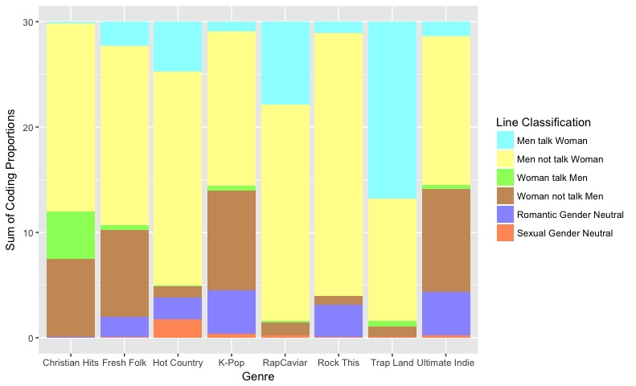

The y axis details the sum of the various proportions; each sum adds up to 30 since we coded 30 songs be genre category with the colors specifying what category that proportion amount was classified as. The x axis is specifying what bar corresponds to which genre.

The graphic clearly shows a strong preference for male singers since “Men talk Woman” and “Men not talk Woman” are the most prevalent categories, with latter outweighing the former. The genre with the highest “Woman talk Men” category is Christian Hits, unsurprising given the subject of this genre is the Christian God and/or Jesus Christ which are gendered as male. When there’s an increase in female singers between a category, “Woman not talk Men” seems to increase much more than “Woman talk Men”. The genres with the highest presence of “Romantic Gender Neutral” were K-Pop, Rock This, and Ultimate Indie while Trap Land, RapCaviar and Christian hits had little to none. “Sexual Gender Neutral” with the highest amount in Hot Country with less than 5% presence within that genre.

Given a hierarchical data structure and the numerical data in the form of a proportion, a simple Chi squared for independence or multivariate regression will not suffice. Additionally, each song line isn’t necessarily independent from the next which impacts our ability to use the various proportions as a response variable to genre. We chose a multinomial probit model which estimates the probability of switching genre classification given a change in proportion category. The equation approach is as follows: 

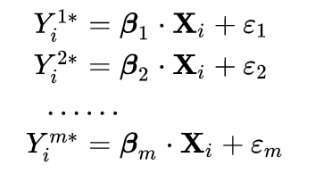With the resulting equations in the format to the right. Each Beta represents the influence of one coding category while the resulting Y is the probability of switching from “Christian Hits” to another genre.

### Multinomial Probit Model

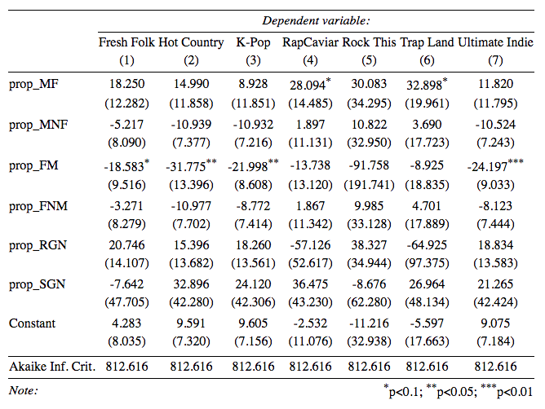 While there is no standard interpretation for an Akaike’s Information Criterion value, the lower the value the more accurate the model is. Given a value of 812.616 for each equation, our model is considered inaccurate. Furthermore, there are only three beta values that are statistically significant with p-values < 0.05. I suspect this is a reaction to singer gender distributions and, therefore, statistical noise. The following graphic shows that distribution.

### Singer Gender Analysis

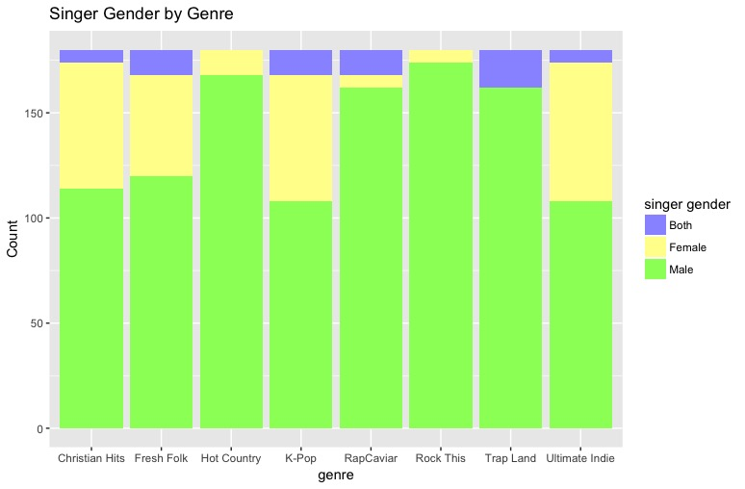

I performed a Pearson’s Chi Squared test with 14 degrees of freedom. The resulting X^2 = 256.05 with a p-value < 2.2e-16 meaning we are 95% confident that the counts of each singer gender category are significantly different from each other.

### Song Content by Singer Gender

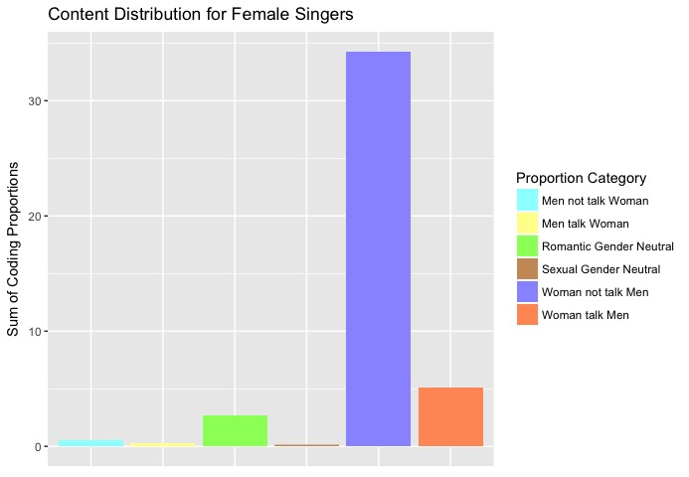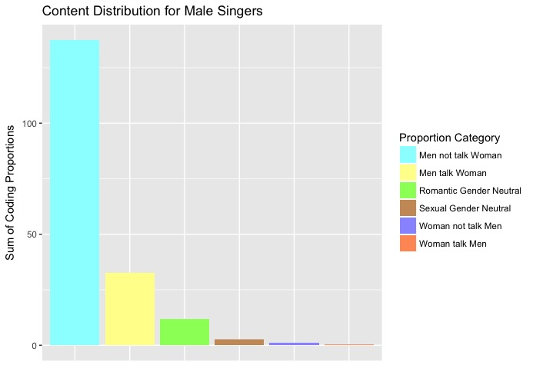

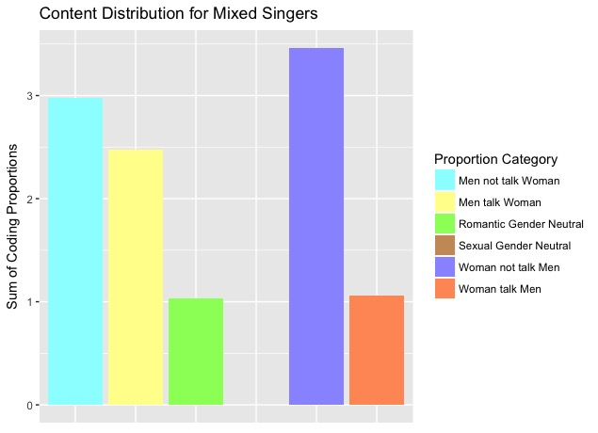

Given the low counts within each of the gender categories, a statistical test isn’t appropriate. However, the graphics show that the majority of the songs aren’t romantic, sexual, or about the opposite sex. The few songs with different gendered singers shows that men tend to talk about the opposite sex more than women do with relatively little romantic lines and no sexual lines.

# Conclusions

From the beginning, the media industry has made a profit in objectifying women. This can be seen in the movies we watch, in popular advertisements and as our study sought to reveal, in the very music that we listen to. For example, the Grammy music awards are meant to recognize, and reward, artists for their hard work in the past year. Particularly, 2017 was an amazing year for the visibility of the women condition as it pertains to sexual harassment and patronization that is frequently overlooked; however, instead of the best song of the year going to a strong female artist, the award went to Ed Sheeran’s ‘Shape of You’ which perpetuates the objectification of women rather than discloses it. In conjunction, the best album of the year award went to Bruno Mars for his rhythmic ballads and female exploitive undertones. So then, what does this say about the female movement towards equality?

Ultimately, our study was statistically insignificant, but it provided us with a basis in which to engage with a dialogue that we otherwise couldn’t have been a part of—dialogue that seeks to expose female objectification rather than reward it. Through our data collection, we realized that not only are there more male artists than female artists, but many of the songs we coded involved the male talking about anything else as well as the female not talking about the opposite gender. In this sense, our hypothesis was wrong, because we anticipated rap caviar and hot country to be the genres that talked about women the most when they turned out to be relatively equal. Although our hypothesis was wrong, it is still a step in the right direction for women as this means that men aren’t making money through the objectification of women as much as they used to. This can be seen in the presence of two Kendrick Lamar songs in the top 100 spotify playlist that consist of Lamar speaking about a woman once throughout the entire song. The reason this is worth noting is because Kendrick Lamar is a rap icon that holds a lot of influential value in the music world, so for him to be at the top with songs that don’t involve degrading women in a huge event. Within this aspect of our coding scheme, ‘man talking about women’, we realized that man could be talking about a woman but not necessarily objectifying her, because in reference to the Lamar songs: the women he mentions is his mother. For the future, we would make our coding scheme more elaborate, so that we could account for this nuance as well as hone in on how much objectification is present in popular music.

# References

Anthony F. Bogaert, Deborah A. Turkovich and Carolyn L. Hafer, *A Content Analysis of "Playboy" Centrefolds from 1953 through 1990: Changes in Explicitness, Objectification, and Model's Age* retrieved from<https://www.jstor.org/stable/3812610?Search=yes&resultItemClick=true&searchText=objectification&searchText=in&searchText=coding&searchUri=%2Faction%2FdoBasicSearch%3FQuery%3Dobjectification%2Bin%2Bcoding&refreqid=search%3A093dda736c688567c508957c4733b1fb&seq=1#page_scan_tab_contents>

Alan McKee, *The Objectification of Women in Mainstream Pornographic Videos in Australia* retrieved from [https://www.google.com/url?q=https%3A%2F%2Fwww.jstor.org%2Fstable%2F3813780%3FSearch%3Dyes%26resultItemClick%3Dtrue%26searchText%3Dobjectification%26searchText%3Din%26searchText%3Dcoding%26searchUri%3D%252Faction%252FdoBasicSearch%253FQuery%253Dobjectification%252Bin%252Bcoding%26refreqid%3Dsearch%253Aa136e5d3ea219046129a9f977bf31232%26seq%3D1%23page_scan_tab_contents](https://www.jstor.org/stable/3813780?Search=yes&resultItemClick=true&searchText=objectification&searchText=in&searchText=coding&searchUri=%2Faction%2FdoBasicSearch%3FQuery%3Dobjectification%2Bin%2Bcoding&refreqid=search%3Aa136e5d3ea219046129a9f977bf31232&seq=1#page_scan_tab_contents)

Sean Williams*, Constructing Gender in Sundanese Music retrieved from* <https://www.jstor.org/stable/768554?Search=yes&resultItemClick=true&searchText=gender&searchText=in&searchText=music&searchUri=%2Faction%2FdoBasicSearch%3FQuery%3Dgender%2Bin%2Bmusic&refreqid=search%3A980209304841de8fdcfd8d0a28463167&seq=1#page_scan_tab_contents>

Chris Walton and Stephanus Muller, *Gender and Sexuality in South African Music*. Ed. retrieved from<http://muse.jhu.edu/article/205567>

F. (2009, December 07). The Bechdel Test for Women in Movies. Retrieved April 18, 2018, from <https://www.youtube.com/watch?v=bLF6sAAMb4s>

McIntyre, H. (2017, November 09). Americans Are Spending More Time Listening To Music Than Ever Before. Retrieved April 18, 2018, from <https://www.forbes.com/sites/hughmcintyre/2017/11/09/americans-are-spending-more-time-listening-to-music-than-ever-before/#19389902f7f8>